 | Epsom & Ewell F.C.  v  Cove  TUesday 8th March 2011
For this evening’s Combined Counties League match we welcome the players, officials and supporters of Cove F.C. today's officials, and our own regular supporters to Moatside.

This is of course their second visit, following a wasted journey back in November where the game was controversially called off just before kick off on a dry, sunny day. We of course, have also been to Cove twice this season, where we have produced two of our better performances in a 2-1 League Cup win, and a 1-0 League win last month. This has substantially improved our record at Oak Farm, which was not the greatest.

On Saturday we were defeated by a last gasp goal from Camberley Town. While our second half performance was exciting and maybe worthy of earning a draw, it must be remembered that the first half was again a poor one, and it would be nice to see us get out of the blocks a bit quicker at times.

It’s nearly here. Eight Epsom & Ewell F.C. Supporters are making the fifteen-mile journey from Epsom to Guildford City in four days time, and fund-raising is going well. For those of you who don’t look regularly at our fund-raising page each week, might like to take a look at the running total this week as we have made a huge step towards our target of £7,000 this season. For anyone that is interested in helping out we will be at the Clock Tower for 8.00 a.m., and if you have the day spare, you could always travel with the support bus. It’s like getting a free coach journey to an away game. Sort of!

Steve Dyke has created a website on www.justgiving.com, under the name of Stephen Dyke, and it’s not too late to support us. A thank you also goes out to the players, who have so far pledged £160 between them. Remember, you can also allow Gift Aid, which is very lucrative for both Mencap and us.

Three weeks tonight we play at Raynes Park Vale and have a large football quiz there in the evening. If you really know your stuff, or even think you do, then contact Pete Lumm who is putting a team together, and if there are plenty of interested parties we could even get two teams. I’d also really like to see one from our players, and as many other teams in our League as possible.

Following the trip to Guildford we return here to play Chertsey Town on 15th March, and follow that with home games against Hanworth Villa and Horley Town on the 19th and 22nd respectively before our match at Raynes Park Vale.

Enjoy the game!

Richard

Cover photo by Joon Wong

Kyle Hough celebrates his equaliser
against Camberley Town on Saturday.

Cherry Red Records Combined Counties League
Premier Division Table
inc Saturday 5th March | P | W | D | L | F | A | Pts | GD
Guildford City | 28 | 20 | 6 | 2 | 73 | 29 | 66 | +44
Chertsey Town | 29 | 21 | 1 | 7 | 69 | 30 | 64 | +39
Camberley Town | 27 | 18 | 3 | 6 | 73 | 33 | 57 | +40
Molesey | 26 | 17 | 4 | 5 | 68 | 29 | 55 | +39
Badshot Lea | 29 | 15 | 7 | 7 | 65 | 41 | 52 | +24
Sandhurst Town | 26 | 13 | 7 | 6 | 54 | 37 | 46 | +17
Hanworth Villa | 29 | 13 | 4 | 12 | 61 | 43 | 43 | +18
Egham Town | 28 | 14 | 3 | 11 | 68 | 46 | 42* | +22
Epsom & Ewell | 27 | 11 | 5 | 11 | 41 | 44 | 38 | -3
Chessington & Hook | 26 | 12 | 4 | 10 | 44 | 48 | 37** | -4
Mole Valley SCR | 26 | 9 | 9 | 8 | 48 | 45 | 36 | +3
Cove | 26 | 10 | 5 | 11 | 39 | 42 | 35 | -3
Ash United | 30 | 9 | 7 | 14 | 38 | 58 | 34 | -20
Horley Town | 29 | 9 | 6 | 14 | 41 | 55 | 33 | -14
Colliers Wood United | 26 | 8 | 7 | 11 | 40 | 44 | 31 | -4
Raynes Park Vale | 26 | 8 | 6 | 12 | 37 | 57 | 30 | -20
Wembley | 27 | 7 | 5 | 15 | 31 | 56 | 26 | -25
Banstead Athletic | 29 | 7 | 4 | 18 | 38 | 65 | 25 | -27
Croydon | 28 | 7 | 5 | 16 | 38 | 64 | 22*** | -26
Dorking | 29 | 4 | 5 | 20 | 32 | 80 | 17 | -48
Bookham | 27 | 3 | 5 | 19 | 27 | 79 | 14 | -52
*** Croydon ineligible player, 3 points deducted - Croydon failed to fulfil fixture v Molesey 1 point deducted
** Chessington & Hook United ineligible player, 3 points deducted
* Egham Town ineligible player, 3 points deducted
Lucky Day? – 8th March
Played 12 - Won 4 Drawn 2 Lost 6 - F12 A23 - PPG 1.17 - BelowAverage
Club record against today’s opponents
Played 23 - Won 11 Drawn 7 Lost 5 - F 56 A 38 - PPG 1.74 - Good
Last Visit
13th March 2010 - Won 2-1 - Combined Counties League

First Eleven Appearances - (max 36)
Name | Debut | 2010/11 |  |  |  | Career Totals
Name | Debut | App | Sub | Total | Goals | App | Sub | Total | Goals
AMARA Hinga | 01/03/11 | 1 | 1 | 2 | 0 | 1 | 1 | 2 | 0
AMFO-BROBBEY Andy | 10/12/05 | 0 | 1 | 1 | 0 | 25 | 17 | 42 | 8
BANYARD Russell | 29/01/11 | 1 | 2 | 3 | 0 | 1 | 2 | 3 | 0
BEDJ BEDJ Ramzi | 08/08/09 | 18 | 1 | 19 | 5 | 53 | 3 | 56 | 17
BORG Paul | 14/08/07 | 29 | 0 | 29 | 0 | 173 | 0 | 173 | 0
CHAPMAN Matt | 29/01/08 | 0 | 1 | 1 | 0 | 8 | 9 | 17 | 0
CORMACK Dan | 16/10/10 | 0 | 4 | 4 | 0 | 0 | 4 | 4 | 0
CUFF Tony | 07/08/10 | 26 | 2 | 28 | 2 | 26 | 2 | 28 | 2
FENNESSEY Terry | 18/09/10 | 5 | 0 | 5 | 0 | 5 | 0 | 5 | 0
FOWLER Matt | 07/08/10 | 4 | 12 | 16 | 2 | 4 | 12 | 16 | 2
GALLAGHER Josh | 30/12/10 | 1 | 1 | 2 | 0 | 1 | 1 | 2 | 0
HARROWING Neil | 15/08/06 | 7 | 0 | 7 | 0 | 35 | 5 | 40 | 0
HATFIELD Jamie | 11/11/06 | 11 | 1 | 12 | 0 | 132 | 7 | 139 | 5
HAYWARD Ben | 07/03/07 | 20 | 5 | 25 | 1 | 155 | 14 | 169 | 8
HENNESSEY Dale | 01/03/11 | 2 | 0 | 2 | 0 | 2 | 0 | 2 | 0
HEWSON Gary | 18/09/10 | 1 | 1 | 2 | 0 | 1 | 1 | 2 | 0
HOLDEN Jay | 30/10/10 | 3 | 4 | 7 | 2 | 3 | 4 | 7 | 2
HOUGH Kyle | 14/08/07 | 29 | 2 | 31 | 16 | 166 | 9 | 175 | 83
JARMAN Mark | 08/08/09 | 20 | 3 | 23 | 10 | 32 | 17 | 49 | 17
JELLEY Tom | 11/02/06 | 18 | 6 | 24 | 0 | 25 | 7 | 32 | 0
MCGREGOR Alex | 08/08/09 | 20 | 12 | 32 | 4 | 55 | 24 | 79 | 6
MOORHOUSE Tommy | 06/03/10 | 8 | 2 | 10 | 2 | 11 | 3 | 14 | 2
NG’BALE Phil | 18/03/06 | 0 | 1 | 1 | 0 | 23 | 10 | 33 | 11
PANAYI Anthony | 14/11/10 | 10 | 0 | 10 | 0 | 10 | 0 | 10 | 0
PARIS Joe | 07/08/10 | 21 | 5 | 26 | 1 | 21 | 5 | 26 | 1
READ Chris | 21/02/04 | 0 | 2 | 2 | 0 | 80 | 7 | 87 | 8
REIVE Jamie | 10/10/09 | 18 | 0 | 18 | 2 | 48 | 1 | 49 | 3
RODRIGUES Alex | 05/04/07 | 36 | 0 | 36 | 0 | 199 | 0 | 199 | 2
SAMMUT Dean | 07/08/10 | 12 | 4 | 16 | 0 | 12 | 4 | 16 | 0
SMITH Darren | 27/08/07 | 13 | 0 | 13 | 3 | 39 | 1 | 40 | 10
SMITH Matt | 08/08/09 | 8 | 9 | 17 | 0 | 45 | 17 | 62 | 1
SOLOMON Peter | 07/08/10 | 0 | 2 | 2 | 0 | 61 | 23 | 84 | 2
STEVENS Dave | 16/10/10 | 12 | 3 | 15 | 6 | 12 | 3 | 15 | 5
SYMES Steve | 19/10/10 | 14 | 2 | 16 | 0 | 14 | 2 | 16 | 0
WEST Charlie | 14/08/07 | 11 | 0 | 11 | 2 | 130 | 5 | 135 | 8
WEST Paul | 17/08/10 | 17 | 7 | 24 | 0 | 17 | 7 | 24 | 0
Own goals |  |  |  |  | 2

From behind the goal
Epsom & Ewell 1-2 Camberley Town - Combined Counties League
Saturday 5th March 2011

Epsom's second half display got them back into this match, only to be undone at the end by a 94th minute goal.

The Blues were looking to bounce back following the midweek loss at Dorking. New signing Hinga Amara started up front this week in place of the injured Matt Fowler, while Ramzi Bedj Bedj returned from suspension at the expense of Alex McGregor, who dropped to the bench.

However, it was a lacklustre start from the home team, and Paul Borg was forced into an acrobatic flying save as early as the eighth minute. He was in action again three minutes later, but this time with less success as he dived at the feet of a Camberley player and brought him down for the penalty. Fortunately, our excellent keeper redeemed himself with a fine save low to his left.

But we didn't heed the warnings, and our chances were only sporadic. Kyle Hough got in front of his man but couldn't glance his header from Hennessey's cross on target after 33 minutes and Bedj Bedj fired high and wide from a narrow angle after some of his left-wing trickery.

And so after 38 minutes it was no real surprise when Camberley took the lead, although the circumstances were disappointing. A very good right wing cross was headed in from close range, but the only way the striker would have missed was if he had been put off by his team mate standing next to him, as our defenders were nowhere to be seen.

The half ended with mysterious bookings for Tony Cuff and Kyle Hough, while Paul West and the visiting keeper had plenty to say to each other as the whistle blew to end the half, but the second half started better for our boys. Amara had struggled with the Camberley offside trap in the first half, but began to find ways through it, and he got clean through after 47 minutes, just placing his shot wide under considerable pressure from the defender.

Was it a penalty? Some thought so, but if it had been awarded, the referee would have had to brandish a red card, and I think that the challenge was not so clear cut that the referee could make that decision, although he did make other confusing ones during the match.

One decision that was easy to make was a yellow card for Ben Hayward. It

was the sort of challenge that you knew was one of Ben's before you were able to actually confirm the identify of the player himself, and on another day the punishment could have been worse. The game was becoming a feisty affair, but the tide was beginning to turn in our favour, as we were starting to find gaps that didn't exist in the first half.

On 65 minutes I thought we would equalise. Bedj Bedj got free on the left hand side of the penalty area, and cut back, completely losing his man Dennis Bergkamp style. However, the keeper was out quickly to block his shot, which just lacked a little height. Moments later Amara was taken out by a crude challenge in the penalty area, but he had let the ball get away from him, and the referee maybe waved play on for that reason. However, if that had been in the middle of the field it would have been a foul ten times out of ten.

Fortunately we weren't to be behind for much longer. McGregor replaced Cuff on the right, and a pinpoint cross with almost his first touch was met by another glancing header from Hough, but this one gave the keeper no chance from close range. (see front cover)

As with the League Cup game between the two back in January, the momentum switched at that point and this time the game was there for Epsom to win it. However, Bedj Bedj was just wide with one shot, and two great defensive blocks of shots, firstly from Amara, and then from the substitute Andy Amfo-Brobbey kept us out. Hough hit the side netting from a narrow angle on two occasions and Hayward was over with an admittedly difficult header.

As time ticked down though the visitors had one last trick. Their player was around twenty yards out and there was an element of handball surrounding his control of the ball, but he then hooked the ball over everyone on the turn and it looped over Borg into the net for the winning goal on 94 minutes.

You could say that we were unfortunate to lose over the course of the ninety minutes. However, there are two things we have to learn before you could say that we are truly unfortunate. Firstly, we must start games better. We can play some great football but we are not built to chase games. Being a goal down is becoming a bit of a habit., especially here at Moatside.

Secondly, we must take our chances when we have the momentum. At Dorking we were a goal up and controlling things but chances came and went before we were pulled back, and in the last fifteen minutes here we could have had another three goals, but scoring just one goal a game is not enough with our current defensive record.

Recent Results and Fixtures
Combined Counties League – Thursday 3rd March
Chessington & Hook United | 0-4 | Banstead Athletic
Combined Counties League – Saturday 5th March
Badshot Lea | 0-2 | Colliers Wood United
Banstead Athletic | 3-0 | Ash United
Chessington & Hook United | 1-1 | Hanworth Villa
Cove | 1-4 | Egham Town
Croydon | 1-1 | Bookham
Dorking | 1-2 | Wembley
Epsom & Ewell | 1-2 | Camberley Town
Horley Town | 0-0 | Raynes Park Vale
Molesey | 1-2 | Guildford City
Sandhurst Town | 1-1 | Mole Valley SCR
Surrey Senior Cup QF – Tuesday 8th March
Raynes Park Vale | V | Metropolitan Police
Combined Counties League – Tuesday 8th March
Ash United | V | Chertsey Town
Badshot Lea | V | Hanworth Villa
Camberley Town | V | Sandhurst Town
Chessington & Hook United | V | Guildford City
Dorking | V | Bookham
Epsom & Ewell | V | Cove
Mole Valley SCR | V | Egham Town
Wembley | V | Croydon
Combined Counties League – Saturday 12th March
Camberley Town | V | Mole Valley SCR
Chertsey Town | V | Sandhurst Town
Colliers Wood United | V | Chessington & Hook United
Dorking | V | Raynes Park Vale
Egham Town | V | Bookham
Guildford City | V | Epsom & Ewell
Hanworth Villa | V | Banstead AThletic
Horley Town | V | Croydon
Molesey | V | Badshot Lea
Wembley | V | Cove
Combined Counties League – Tuesday 15th March
Banstead Athletic | V | Colliers Wood United
Chessington & Hook United | V | Ash United
Cove | V | Bookham
Dorking | V | Camberley Town
Epsom & Ewell | V | Chertsey Town
Molesey | V | Hanworth Villa
Mole Valley SCR | V | Croydon
Combined Counties League – Wednesday 16th March
Raynes Park Vale | V | Guildford City
Combined Counties League – Saturday 19th March
Ash United | V | Egham Town
Badshot Lea | V | Wembley
Banstead Athletic | V | Dorking
Bookham | V | Sandhurst Town
Camberley Town | V | Horley Town
Cove | V | Molesey
Croydon | V | Chertsey Town
Epsom & Ewell | V | Hanworth Villa
Mole Valley SCR | V | Chessington & Hook United
Raynes Park Vale | V | Colliers Wood United
Combined Counties League – Tuesday 22nd March
Banstead Athletic | V | Mole Valley SCR
Bookham | V | Wembley
Camberley Town | V | Molesey
Chessington & Hook United | V | Sandhurst Town
Epsom & Ewell | V | Horley Town
Combined Counties League – Wednesday 23rd March
Colliers Wood United | V | Cove
Guildford City | V | Egham Town
Combined Counties League – Saturday 26th March
Chertsey Town | V | Mole Valley SCR
Chessington & Hook United | V | Bookham
Colliers Wood United | V | Camberley Town
Croydon | V | Badshot Lea
Dorking | V | Cove
Egham Town | V | Hanworth Villa
Horley Town | V | Guildford City
Molesey | V | Ash United
Raynes Park Vale | V | Epsom & Ewell
Sandhurst Town | V | Banstead Athletic

On This Day - 8th March
81 years ago today Tooting Town visited us for a London League match and went away with a 2-1 victory. It was a close game and much improved on our recent 4-2 Surrey Senior Cup defeat at Sandy Lane, with Jack Parr scoring on his return from injury.

53 years ago today the Blues reached a Corinthian League Memorial Shield Semi-Final, after having defeated the holders and this season’s League Champions Maidenhead United 5-0 in the Quarter-Final. However, this was a different story and Ken Harris’s first half goal looked meek in comparison to Yiewsley’s five!

But where is Yiewsley and what happened to them? Well, it is in Middlesex, and this team went on to better things when they changed their name to Hillingdon Borough, reaching the third Round of the F.A.Cup in 1969/70 before folding in the eighties.

36 years ago today we were right here at Moatside. Actually, not exactly here, as Merstham’s pitch has moved 90 degrees since those days, as you could possibly tell from the position of their small stand at the Albury End. We met in a Surrey Senior League match and were flying at that point. We had just seen off Addlestone in the Quarter-Final of the F.A.Vase and were looking forward to a two-legged Semi-Final with Stamford, but remained professional and saw off Merstham by three clear goals.

25 years ago today Kingstonian were defeated 3-2 in a crucial match for the Blues, who needed the points badly in their relegation fight, one they would ultimately lose. In the previous item, Player/Manager Pat O’Connell scored on this day, while our next Player Manager, (although he didn’t know it at the time) Ricky Kidd, scored here.

17 years ago today Chertsey aided by former International Kenny Sansom, eased past the Blues into the Semi-Finals of the Associate Members trophy after our heroics in the previous round at Aldershot.

Date | Day | Competition |  | Opponents | F/T | Scorers
08-Mar-30 | Sat | London League | H | Tooting Town | 1-2 | Parr
08-Mar-58 | Sat | Corinthian League Memorial Shield SF | A | Yiewsley | 1-5 | K.Harris
08-Mar-69 | Sat | Athenian League 2 | H | Wingate | 0-0
08-Mar-75 | Sat | Surrey Senior League | A | Merstham | 3-0 | O'Connell, Walker, Ritman
08-Mar-80 | Sat | Isthmian League 1 | H | Maidenhead United | 0-0
08-Mar-83 | Tue | Isthmian League 1 | H | Aveley | 1-0 | Hill
08-Mar-86 | Sat | Isthmian League Prem | H | Kingstonian | 3-2 | Kidd, Taylor, Walker
08-Mar-88 | Tue | Isthmian League 2s | A | Banstead Athletic | 2-1 | Flack (pen), Harding
08-Mar-94 | Tue | Associate Members Trophy QF | H | Chertsey Town | 0-7
08-Mar-97 | Sat | Isthmian League 3 | A | Braintree Town | 1-4 | Boxall (pen)
08-Mar-03 | Sat | Isthmian League 1s | A | Lewes | 0-1
08-Mar-08 | Sat | Combined Counties Prem Div | A | Guildford City | 0-1

This Week in History
90 years ago this week it was local derby time at the Epsom Recreation Ground, as the Epsom Juniors met their local opponents Epsom Brotherhood but were defeated by two second half goals in a Sutton & District League match. “The Juniors have a fine team and will improve,” said the Epsom Herald. They did!

80 years ago this week Dagenham Town visited West Street, and goals from Reg Marlow and Herbert Pattimore set us off to a good start after just twenty-five minutes. It was just as well as the Blues suffered injuries to Jones and Mackesy, both of whom finished as passengers, and Epsom held on to win 2-1. This Dagenham team were the main team in the town, but folded around war time, and their successors became the team we see in the Football League today.

70 years ago this week the Welsh Guards visited West Street for a friendly, and totally destroyed Epsom Town that day. But this was not a disgrace. The Surrey Herald said Poland (Liverpool and Wales), Bassett and Morris (Swansea), Hodder (Cardiff) and Clark (Walsall) all played, and "they would not have disgraced a First Division XI". Morgan got four goals and Chick got three of the others this day.

20 years ago this week Epsom and Ewell got their own back on Eastbourne United for an earlier 2-0 League defeat, when Epsom had finished with ten men, due to an injury to Scott Buckwell, brother of Lyndon who also played that day. In this game we were three up at half time, and won easily adding a fourth in the second period.

Date | Day | Competition |  | Opponents | F/T | Scorers
90 years ago
26-Feb-31 | Sat | Sutton & District League Premier | A | Epsom Brotherhood | 0-2
80 years ago
07-Mar-31 | Sat | London League | H | Dagenham Town | 2-1 | Marlow, Pattemore
70 years ago – Epsom Town
08-Mar-41 | Sat | Friendly | H | Welsh Guards | 0-8
60 years ago
10-Mar-51 | Sat | Corinthian League | A | Chesham United | 3-8 | Boatwright (2pens), Faggetter
50 years ago
11-Mar-61 | Sat | Corinthian League | H | Chesham United | 0-5
40 years ago
06-Mar-71 | Sat | Athenian League 2 | H | Windsor & Eton | 0-4
30 years ago
07-Mar-81 | Sat | Isthmian League 1 | A | Ware | 2-1 | Gaydon, Auguste
20 years ago
09-Mar-91 | Sat | Isthmian League 2s | H | Eastbourne United | 4-0 | Fry (2, 1 pen),  Purvis, Morris
10 years ago
10-Mar-01 | Sat | Isthmian League 3 | A | Ashford Tn (Mx) | 1-0 | Nimmo (pen)

100 Memorable Matches
What makes a memorable match?

A match can leave us with memories for a number of reasons. It could have been a big game like a cup final or promotion decider; or it could have been a wild match with lots of goals, a big win, or even a heavy defeat. Add freak weather conditions, an odd refereeing decision, or just something a little bit special and you have a list of about 500 matches.

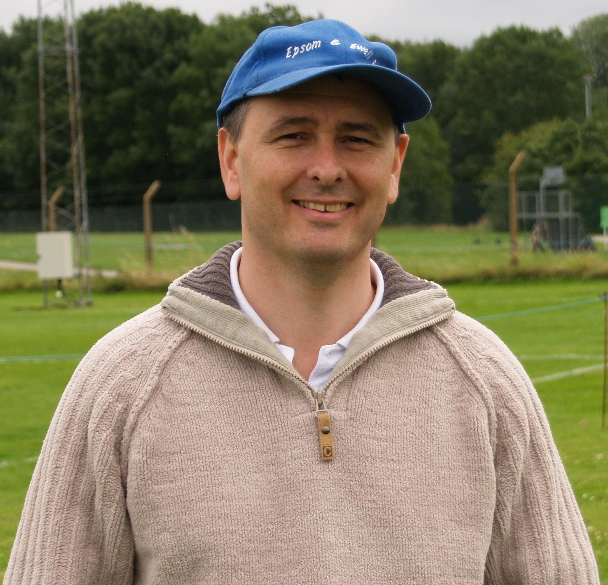
To try and get this list down to 100 has been an extremely difficult task. Occasionally I have put matches together for obvious reasons, as you’ll find out over the course of the season, and by the end of the season, we’ll find out which was top of the list.

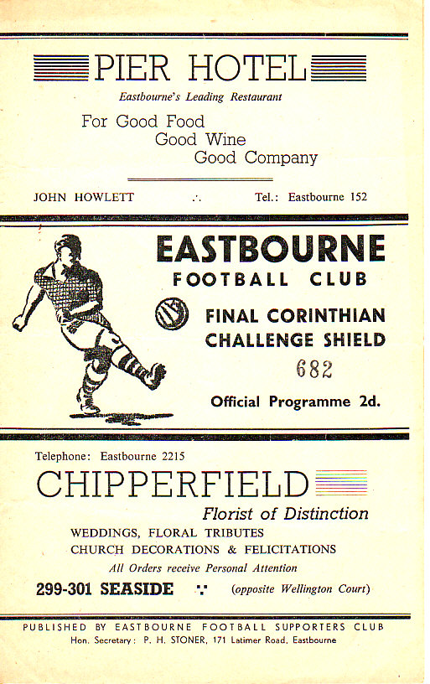
26 – Epsom F.C. 1-2 Hounslow
Corinthian League Memorial Shield Final
Monday 14th April 1952

This was the first significant match in the club’s post-war history. We had entered the Corinthian League in 1949 after a moderately successful season in the London League, but in nearly three years of Corinthian League matches it had taken until January 1952 to record an away win.

This team were growing in confidence, and with new star striker Bill Goddard finding his feet with 42 goals in 33 appearances we defeated his old club Edgware, Eastbourne (after a replay) and in the Semi-Final had crushed Maidenhead United 8-1 (memorable matches number 47).

In the Corinthian League’s wisdom, they decreed that the Final between two London area clubs would be played at… you guessed it, Eastbourne! Despite this, an enormous crowd of 5,000 were present, and they saw Epsom take the lead after 29 minutes when Denis Ford converted a Tommy Rochester cross, but two goals in the 73rd and 74th minutes were cruel, and although Reg Walker hit the bar near the end we were unable to force extra time. Three weeks later the League title also went Hounslow’s way to complete the double.

25 – Epsom and Ewell 0-4 Sutton United – Surrey Senior Cup Final
Monday 23rd April 1984

My overriding memories of this match were that I had a temperature of over a hundred and it was also a baking hot Easter Monday at Imber Court.

It was a big match for the Blues. Just three years previously we had won the Cup for the first time, and we were looking good for promotion to the Isthmian League Premier

Division too. To reach this stage we had required a replay to see off Addlestone and Weybridge at Liberty Lane, followed by a Quarter-Final at Merland Rise where we had defeated Banstead Athletic 3-0.

The Semi-Final against Croydon was tinged with revenge, as we had lost our grip on the trophy in 1982 to them just after the Pat O’Connell walk out, and we had hardly anyone eligible. This time we led two-nil at the Croydon Arena, one of which was a screamer from Alan Morton, but the higher Division side fought back for a 2-2 draw. Fortunately a Steve Hill hat trick finished them off 3-1 in the replay at West Street.

However, Sutton were far too good on the day of the final, and an Epsom side with possibly one eye on promotion anyway had just secured a tough 1-1 draw at Wembley, so in my opinion we just needed to stay injury-free to go up. Maybe this had something to do with our limp display and we went down by four clear goals in front of over 1,000 paying spectators.
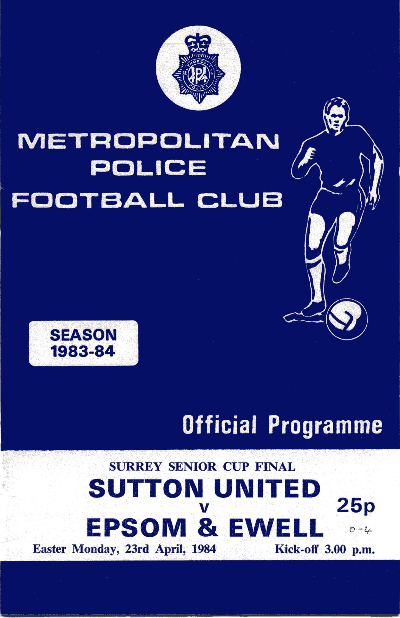
24 – Epsom F.C. 0-2 Corinthian Casuals - Surrey Senior Cup Final
Saturday 8th May 1954

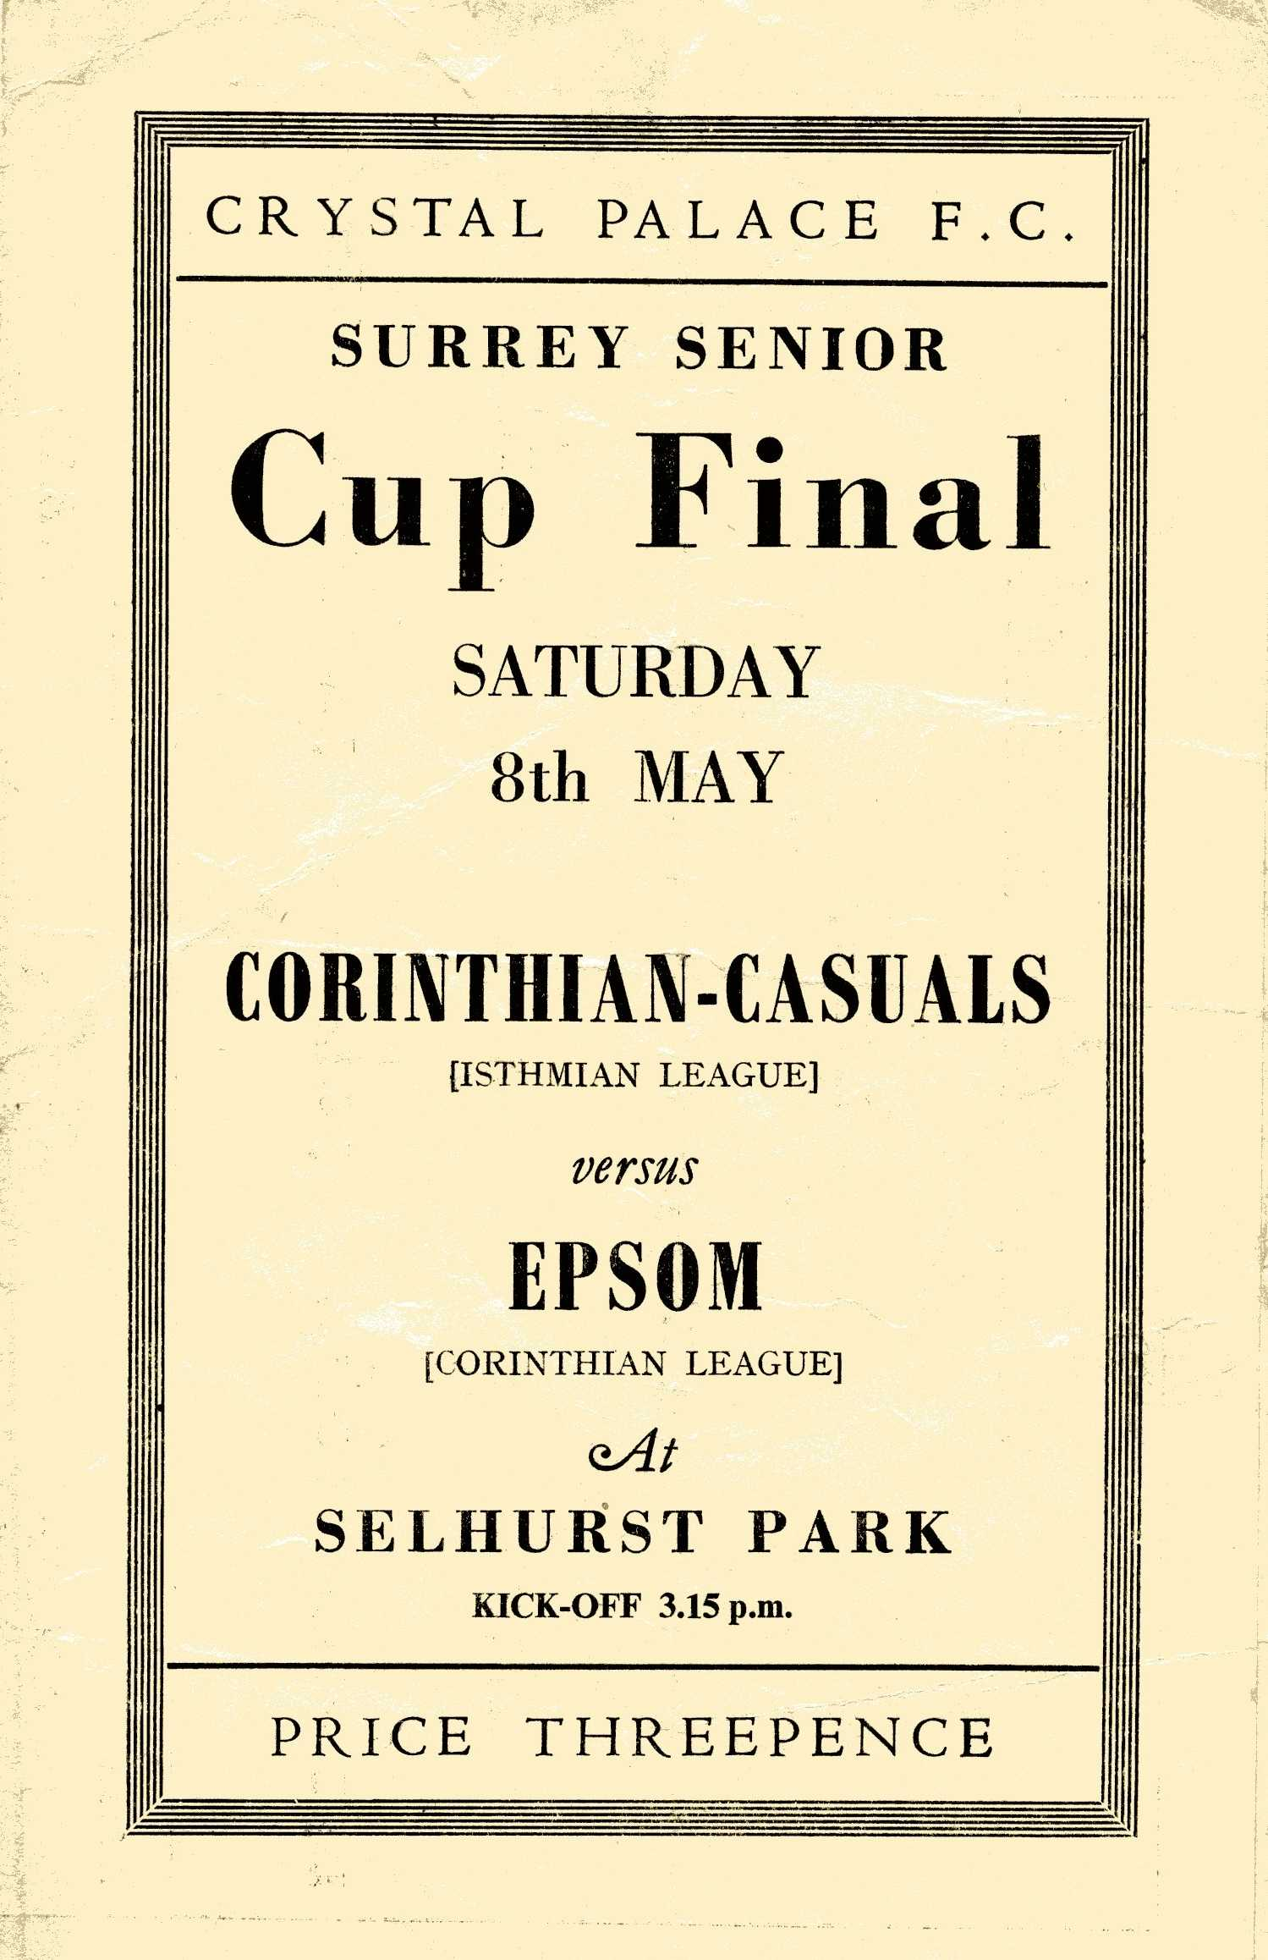
Again this match was shrouded in controversy. “Why do we have to play this at Selhurst Park?” said the local papers. It’s too far away, was the general view. This was borne out a little by the crowd of “just” 6,159, as the Semi-Final against Dulwich had reached 7,000 at Plough Lane.

To reach the Final, the Pat Lynch led Epsom had defeated Addlestone 5-0 and Malden Town 3-0 before two epic battles with Dulwich Hamlet (see memorable matches number 32) that we had negotiated after extra time.

Although the Corinthian Casuals were an Isthmian League side too, they weren’t nearly as powerful as Dulwich, were they? As it turned out, this side was developing into one of the best in the Country, with an Amateur Cup Final awaiting them against the mighty Bishop Auckland two years down the line from this match.

Even taking this into account, the Blues took the game to their opponents, only to be undone with a goal in each half. “We were robbed,” said the papers, but we all know that the best team doesn’t always win!

Suburban League South League Table
inc Saturday 5th March | P | W | D | L | F | A | Pts | GD
Corinthian-Casuals | 22 | 16 | 1 | 5 | 58 | 28 | 49 | +30
Chipstead | 24 | 13 | 6 | 5 | 74 | 39 | 45 | +35
Merstham | 20 | 12 | 4 | 4 | 62 | 27 | 40 | +35
Corinthian | 22 | 12 | 2 | 8 | 56 | 38 | 38 | +18
Colliers Wood Utd | 21 | 11 | 5 | 5 | 43 | 32 | 38 | +11
Crawley Down | 23 | 10 | 7 | 6 | 43 | 32 | 37 | +11
East Grinstead Town | 19 | 11 | 3 | 5 | 56 | 20 | 36 | +36
Banstead Athletic | 18 | 11 | 1 | 6 | 40 | 26 | 34 | +14
Cobham | 22 | 11 | 1 | 10 | 44 | 50 | 34 | -6
Crowborough Athletic | 23 | 10 | 3 | 10 | 50 | 63 | 33 | -13
South Park | 24 | 8 | 5 | 11 | 50 | 50 | 29 | 0
Epsom & Ewell | 18 | 8 | 1 | 9 | 36 | 46 | 25 | -10
Molesey | 23 | 7 | 4 | 12 | 41 | 52 | 25 | -11
Chessington & Hook Utd | 16 | 6 | 4 | 6 | 36 | 37 | 22 | -1
Redhill | 21 | 6 | 2 | 13 | 28 | 40 | 20 | -12
Lingfield | 17 | 5 | 2 | 10 | 37 | 35 | 17 | 2
Horley Town | 24 | 2 | 4 | 18 | 22 | 99 | 10 | -77
Oakwood | 19 | 0 | 3 | 16 | 20 | 82 | 3 | -62
Whitehawk | Withdrawn - Record expunged

2nd XI Fixtures 2010/11
1 | 28/08/10 | Sat | East Grinstead Town | SL | 3-2 | Boniface, Solomon, Ng'bale
2 | 04/09/10 | Sat | Whitehawk | SL | 0-2
3 | 13/09/10 | Mon | Redhill | SL | 1-0 | Hayward
4 | 18/09/10 | Sat | Three Bridges | SLC 1 | 4-1 | Okolie, Binns, Adewale Solomon
5 | 25/09/10 | Sat | Crawley Down | SL | 1-3 | Adewale
6 | 29/09/10 | Wed | Colliers Wood United | SPC 1 | 2-3 | ??
7 | 04/10/10 | Mon | COLLIERS WOOD UNITED | SL | 2-3 | Boniface, Rains
8 | 09/10/10 | Sat | Lingfield | SL | 4-2 | Stevens (3), Binns
9 | 11/10/10 | Mon | MOLESEY | SL | 5-0 | Stevens (3), Boniface (2)
10 | 16/10/10 | Sat | Corinthian Casuals | SL | 0-3
11 | 18/10/10 | Mon | CHESSINGTON & HOOK UNITED | SL | 3-2 | Stevens, Binns, Ng'bale
12 | 23/10/10 | Sat | South Park | SL | 3-4 | Dinham, Johnson, Lovett
13 | 25/10/10 | Mon | MERSTHAM | SL | 3-4 | Binns, Stevens (2)
14 | 06/11/10 | Sat | Crowborough Athletic | SL | 3-3 | ??
15 | 13/11/10 | Sat | Corinthian Casuals | SLC 2 | 1-2 | Holden
16 | 20/11/10 | Sat | Corinthian | SL | 3-0 | ??
17 | 14/12/10 | Tue | Cobham | SL | 0-1
18 | 22/01/11 | Sat | Chipstead | SL | 0-8
19 | 26/01/11 | Wed | Merstham | SL | 1-7 | ??
20 | 31/01/11 | Mon | SOUTH PARK | SL | 1-0 | ??
21 | 05/02/11 | Sat | Horley Town | SL | 2-1 | Max Smith, o.g.
22 | 07/02/11 | Mon | CORINTHIAN | SL | 1-3 | ??
23 | 07/03/11 | Mon | CRAWLEY DOWN | SL
24 | 12/03/11 | Sat | Chessington & Hook United | SL
25 | 14/03/11 | Mon | CHIPSTEAD | SL
26 | 19/03/11 | Sat | Colliers Wood United | SL
27 | 21/03/11 | Mon | OAKWOOD | SL
28 | 23/03/11 | Wed | REDHILL | SL
29 | 26/03/11 | Sat | Oakwood | SL
30 | 28/03/11 | Sat | HORLEY TOWN | SL
31 | 04/04/11 | Mon | LINGFIELD | SL
32 | 09/04/11 | Sat | Molesey | SL
33 | 11/04/11 | Mon | CORINTHIAN CASUALS | SL
34 | 16/04/11 | Sat | Banstead Athletic | SL
35 | 23/04/11 | Sat | BANSTEAD ATHLETIC | SL |  | Playing at Banstead
36 | 30/04/11 | Sat | COBHAM | SL
37 | Tba |  | CROWBOROUGH ATHLETIC | SL
38 | tba |  | EAST GRINSTEAD TOWN | SL
SL - Suburban League SPC - Surrey Premier Cup SLC - Suburban League Cup

Suburban League Cup
Third Round
Woking | 3-1 | Northwood
East Grinstead Town | 5-0 | Chessington & Hook United
South Park | 2-3 | Tring Athletic
Eastbourne Borough | 4-3 | Corinthian Casuals
Cobham | 0-2 | Uxbridge
Hampton & Richmond Borough | 9/3 | Beaconsfield Sycob
Chalfont St Peter | 7/3 | Leighton Town
Sutton United | 4-1+ | Leatherhead
Quarter - Finals
Hampton & Richmond Borough / Beaconsfield Sycob | V | Chalfont St Peter / Leighton Town
East Grinstead Town | V | Tring Athletic
Eastbourne Borough | V | Uxbridge
Woking | V | Sutton United

Youth Team Fixtures 2010/11
All HOME fixtures are to be played at Grand Drive Raynes Park Vale F.C.
1 | 01/09/10 | Wed | Westfield | SYL | 1-2 | Banks (pen)
2 | 06/09/10 | Mon | CHICHESTER CITY | FAYC | 2-1+ | D.Smith, Panayi
3 | 13/09/10 | Mon | Chessington & Hook United | SYL | 4-1 | Nevin (2), Banks, Henry
4 | 16/09/10 | Thur | Balham Blazers | SYL | 1-3 | Tchetche-Santacreu
5 | 20/09/10 | Mon | LANCING | FAYC | 0-5
6 | 27/09/10 | Mon | COBHAM | SYL | 3-2 | Adewale (2), Matheson
7 | 06/10/10 | Wed | Chertsey Town | SYL | 3-5 | Beenham, Nadesan (2)
8 | 14/10/10 | Thur | South Park | SMFC 1 | 0-3
9 | 20/10/10 | Wed | LEWISHAM BOROUGH | SYL | 4-0 | Henry, Matheson,  Nadesan, Jones
10 | 01/11/10 | Mon | Molesey | SYL | 1-1 | Matheson
11 | 05/01/11 | Wed | DORKING | GM 1 | 3-1 | Adewale, o.g., Corbin (pen)
12 | 24/01/11 | Mon | Croydon | SYL | 1-0 | Henry
13 | 03/02/11 | Thur | MERSTHAM | SYLC 2 | 1-2 | ??
 |  |  | Played at Merstham
14 | 10/03/11 | Thur | Cobham | SYL
15 | 17/03/11 | Thur | St Andrews | SYL
16 | 21/03/11 | Mon | CROYDON | SYL
17 | 28/03/11 | Mon | CHERTSEY TOWN | SYL
18 | 30/03/11 | Wed | Tooting & Mitcham United | SYL
19 | 04/04/11 | Mon | WESTFIELD | SYL
20 | 11/04/11 | Mon | COLLIERS WOOD UTD | SYL
21 | 13/04/11 | Wed | Lewisham Borough | SYL
22 | 18/04/11 | Mon | TOOTING & MITCHAM UNITED | SYL
 | Tba
 | Tba
 | Tba
 |  |  | HARTLEY WINTNEY | GM 2
SYL - Southern Youth League, FAYC - F.A.Youth Cup, GM - Grant McLellan Youth Cup
SYLC - Southern Youth League Cup, SMFC - Surrey Midweek Floodlit Cup

Southern Youth League Table

inc Thursday 9th March | P | W | D | L | F | A | Pts | GD
Balham Blazers | 14 | 9 | 3 | 2 | 51 | 30 | 30 | +21
Chertsey Town | 14 | 9 | 1 | 4 | 48 | 23 | 28 | +25
Westfield | 12 | 7 | 3 | 2 | 29 | 12 | 24 | +17
Croydon | 14 | 6 | 3 | 5 | 36 | 37 | 21 | -1
Cobham | 14 | 5 | 3 | 6 | 30 | 30 | 18 | 0
Tooting & Mitcham Utd | 9 | 4 | 2 | 3 | 29 | 22 | 14 | +7
Molesey | 11 | 4 | 2 | 5 | 23 | 22 | 14 | 1
Colliers Wood Utd | 10 | 3 | 4 | 3 | 23 | 21 | 13 | +2
St. Andrews | 12 | 3 | 4 | 5 | 25 | 29 | 13 | -4
Epsom & Ewell | 8 | 3 | 1 | 4 | 15 | 17 | 10 | -2
Lewisham Borough | 14 | 0 | 0 | 14 | 7 | 73 | 0 | -66
Chessington & Hook United | Withdrawn – Record expunged

Southern Youth League Cup
Quarter Finals
Lingfield | 9/3 | Horley Town
Cranleigh | V | Merstham
Croydon Athletic | 3-1 | Camberley Town
Croydon | 7/3 | Oakwood

A few words from our Manager
There have been a few changes to the Epsom playing squad over the last couple of weeks.

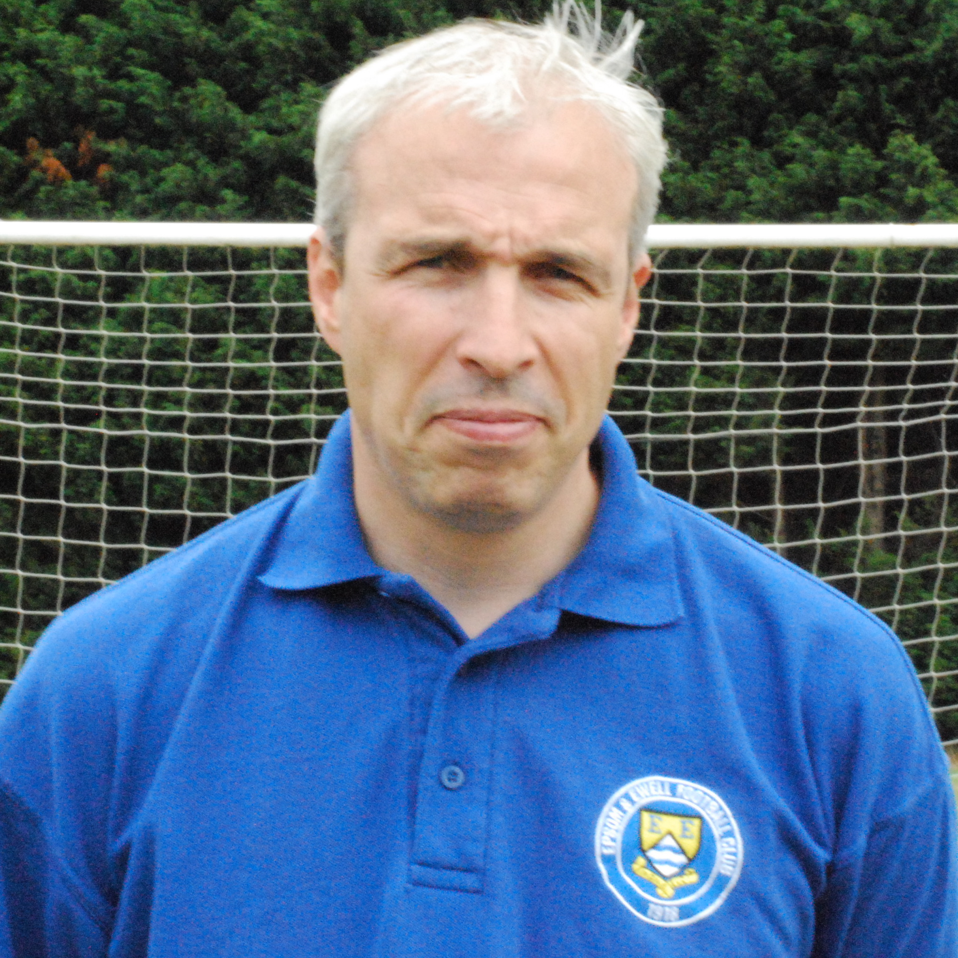
Players who have left the club are defender Richard Webber and midfielder Darren Smith who have both returned to Chessington & Hook United, midfielder Joe Paris who has returned to Camberley Town, and striker Dave Stevens who has been snapped up by Ryman one side Godalming Town.

Players coming into the squad are defenders Dale Henessey from Corinthian Casuals, and Russell Banyard from Merstham. We also welcome striker Hinga Amara to the club from Croydon.

Finally, we welcome back popular and long-serving keeper Neil Harrowing, who had taken some time off to be with his family. Neil’s partner has recently given birth to a baby girl called Lexie, Congratulations Neil!

Congratulations Alex – 200 today!
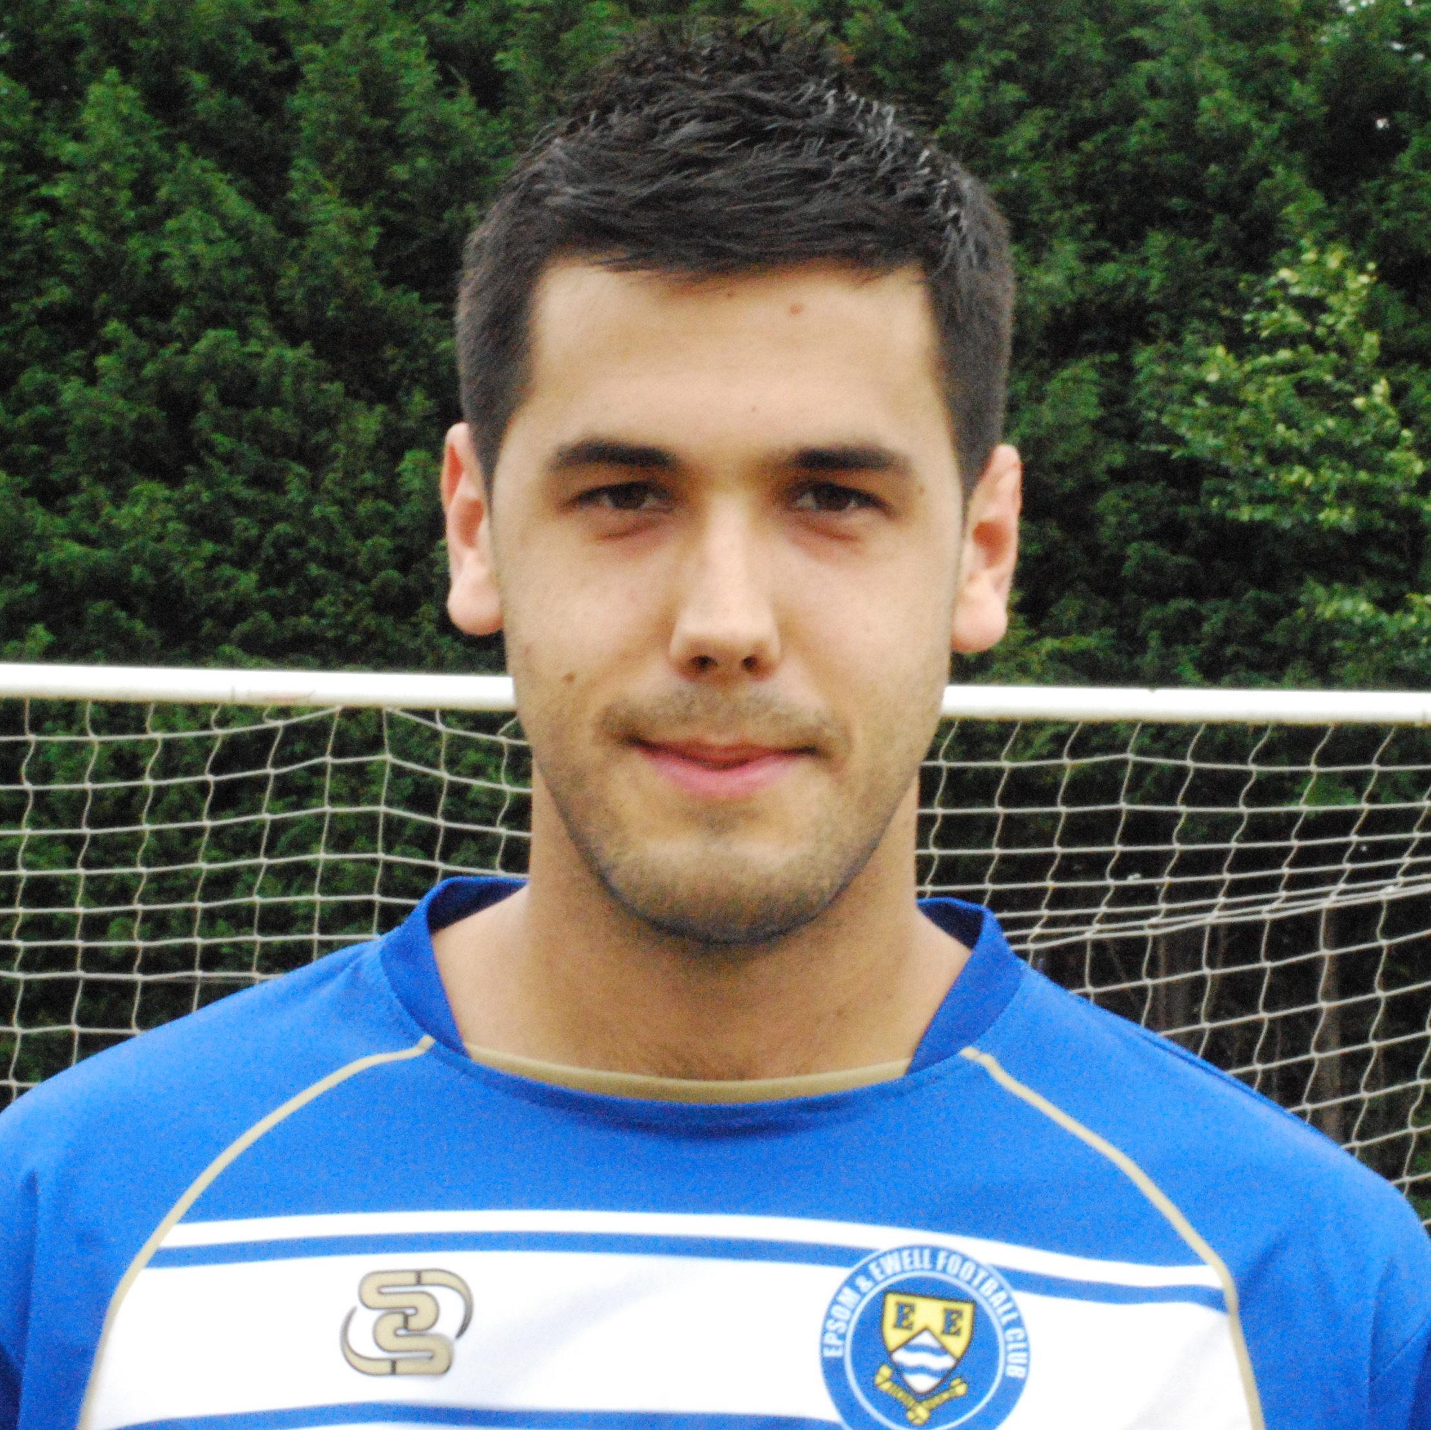
He may not look it, but Alex Rodrigues has been around for quite a while!

We all know about his record-breaking run of consecutive matches that currently sits at 171. However, this evening Alex joins an exclusive club, becoming the thirtieth player in club history to make his 200th appearance for the club, and the first player to do this since Dale Marvell went past this mark in April 2009.

Assuming Alex plays in the thirteen matches that remain after tonight, he would rise to 24th on the all time list. We also have three other players that could get there next season as Ben Hayward, Kyle Hough and Paul Borg are all well over the 150 mark. Well done to all.

Did You Know?
We may not have the greatest record at Moatside since moving here last summer, but did you know that in our eighteen matches this season, we have scored in ALL of them!

Also it must be said that we have not been blessed with the greatest weather. In fact Saturday’s match was the first home match all season where it was:
a) dry all day and b) above freezing at kick off time!

This page for appearances spreadsheet (centre pages)

This page for appearances spreadsheet (centre pages)

Golden Goal Bingo Ticket update
We are now well into Period Three even though we have only played a few games. Here is the current position: Ticket 125 leads the way with five numbers out of ten.

Date | Comp | Opponents | H/A | F/T | Goal Times
01/03/11 | CCL | Dorking | A | 1-3 | 11
05/03/11 |  | Camberley Town | H | 1-2 | 73
08/03/11 |  | Cove | H
12/03/11 |  | Guildford City | A
15/03/11 |  | Chertsey Town | H
19/03/11 |  | Hanworth Villa | H
22/03/11 |  | Horley Town | H
26/03/11 |  | Raynes Park Vale | A
05/04/11 |  | Colliers Wood United | H
09/04/11 |  | Bookham | H
12/04/11 |  | Wembley | H
16/04/11 |  | Horley Town | A
19/04/11 |  | Chessington & Hook United | A
23/04/11 |  | Egham Town | H
28/04/11 |  | Mole Valley SCR | A
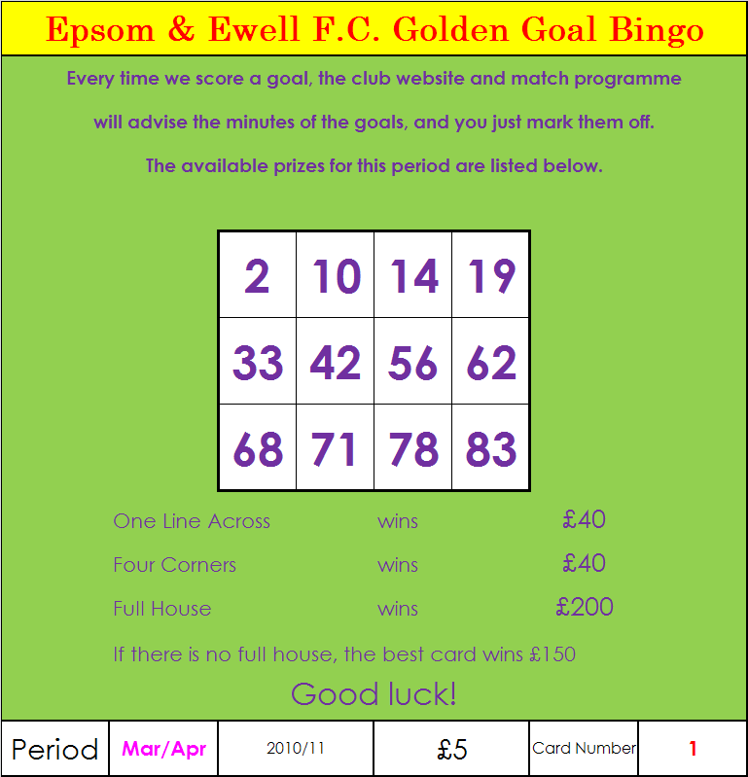
We are now into Period 4!

We sold 137 tickets in this period, which was down on the previous sales, but the postponements, hindered sales opportunities. We sold 165 tickets in total during period 2, and 149 in the first period. Thank you!

Please bear in mind that it is down to all supporters out there to sell as many tickets that they can. Even if just ten of you sold ten at work, then that would raise £500 towards the Fund-Raising Exercise.

On the left is our new ticket, out now. If you want to sell a few to friends and family, just ask.

Supporters Fund Raising Exercise – New Events
Unless you are on a different planet you will be aware that we are trying to raise the substantial sum of £7,000 this season, but WE NEED YOUR HELP. In addition to the items on sale including the Bingo tickets, DVD’s and Legends Books there will be some club badges available in March/April, priced at £5. If you know anyone who would want any of these, please let them know and pass the message on.

The real reason for this article is to announce our two big Fund-Raisers for later this season.
Sponsored Walk

Firstly, The Sponsored Walk to Guildford on 12th March. We have ten confirmed walkers with some others coming from Mencap, but we need more walkers. If we get ten of us all raising the not impossible sum of £100 each, then after splitting 50/50 with Mencap, we will raise £500 for the cause, but if we get twenty, then we could double that. Hopefully more, as a similar exercise raised just over £1,100 back in 2004 when we walked to Chertsey.

The journey is 16 miles by road but Steve Dyke – Walk Co-ordinator is hoping to find a couple of non-road short cuts to bring the trip below 15 miles. If you are interested, please let me know as soon as possible so you have time to get sponsors. If you are not able to walk, then please consider sponsoring a walker. There is also www.justgiving.com with details on the front page.
Quiz

Secondly, following our League match at Raynes Park Vale on 26th March, we will be running a quiz in their clubhouse exclusively on different areas of your favourite subject. No, not that, I mean football!

Entry for a team of up to five people is just £10 (just £2 each), and we will be arranging for food, a raffle, and merchandise to be available as we try and raise a fair sum. Anything that is taken over the bar also counts towards our fund-raising total, so this is a great opportunity. There will also be a couple of decent cash prizes for the top two teams and a trophy for the winning team.

We don’t mind who the teams are comprised from, but are really hoping that a lot of supporters teams come to represent their club. For our part, we would like at least TWO teams of five from our club, one of players, and one of supporters, but more teams would be great, and remember that many of you would be at Grand Drive anyway for the game. Also, any helpers would be welcome as we will need sellers, delivery boys, and scorers / markers.

The event will kick off at 7.30-7.45 and believe me it will be a good quiz covering twelve different rounds with all levels of difficulty being asked. If you want to be part of an Epsom & Ewell F.C. Supporters Team, please see Pete Lumm.

Alan Carter

Finding the right investor

Ownership of football clubs is an emotive issue. As fans we feel the club belongs to us. Yet in the case of the bigger league clubs especially, business people pay an awful lot of money to own clubs like Manchester City and Chelsea.

It goes against the grain but owners who splash the cash to buy a football team have bought the right to run the club as they see fit. However, the problem has been that many of these owners with business backgrounds have proven to be terrible businessmen and what’s worse simply don’t understand what a football club means to its fans and the local community in general.

Also the football authorities have appeared powerless to prevent the wrong people owning clubs. Unfortunately it has been the fans that have suffered the most as they watch on helplessly as their beloved football club suffers both on and off the pitch.

Just look at what happened to Portsmouth. Pompey were driven to the brink of extinction simply because the club was spending more money than it was bringing in. Now, none of us need to be a highflying businessman to know that that is a recipe for disaster.

However in fairness not all rich businessmen invest in clubs with an eye to making money. Robert Rich, a US billionaire, has invested in… non-league Bedlington Terriers of the Northern League.

The 488th richest man in the world could have followed the Glazers, Randy Lerner or John W Henry as Americans who have taken over a Premier league team. But instead the appropriately named Mr Rich chose the unfashionable Northumberland side.

The 69-year-old tycoon got involved after tracing his family back to the area. His wife bought him the title Lord of Bedlington and on further investigation he became interested in the town’s local football team.



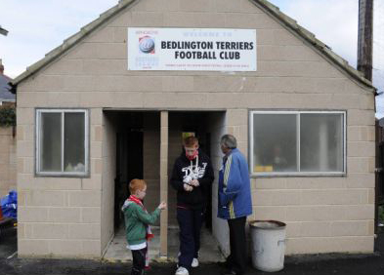
"I got to know the folks in Bedlington and I was impressed by the people and the officers of the club and the fans themselves“ explains Mr Rich*. “They are obviously very passionate about their club and they are a kind of underdogs playing against many teams in their league who are much better financed and yet they have a great optimism about them."

Indeed Mr Rich made a good impression on Bedlington’s fans and club officials as Club Chairman Dave Holmes points out**. “"He came up and watched the home game against Dunston UTS [and] brought his whole family [including] his wife and grandchildren He met the local people, supporters, the committee and was very impressed with the enthusiasm of people here. I think that was the main thing that gave him the encouragement to want to develop further aspects of help,” says Holmes.

As a result the American has become Bedlington’s shirt sponsor, has put in an undisclosed amount of cash into the club and has agreed to ship over a £30,000 scoreboard from one of the baseball teams he owns in the US.

I must admit when I read about Nr Rich’s involvement with Bedlington it has gone some way to changing my opinion of the normally unpopular foreign owners. This is something that Rich himself recognises. "I am very conscious of what has gone on with Liverpool, Man U, Aston Villa and other franchises but this is really the antithesis of that kind of involvement," Rich explained.

"We don't own the club. We are sponsoring the club under the name of Rich's for our company in Great Britain. We have an interest in helping this team do well and helping the people of the area.

"I have no equity in the club but I feel that it is sponsorship that offers a great opportunity to help turn the under-capitalised Bedlington Terriers into winners as opposed to perpetual underdogs."

Hopefully, the Buffalo-based billionaire's generosity will persuade other rich businessmen to help struggling grass-roots clubs rather than chase the glory and headlines. We wouldn’t mind a helping hand after all. Anyone know a rich American who understands English football?

* Interview excerpts with Robert Rich taken from Daily Mail website
** Interview excerpt with Dave Holmes taken from Guardian website

Steve Davies


“Mottos” – By Steve Davies

While writing this I am making an assumption that our new nickname will be “The Salts” so now I thought that I would turn my attention to our Motto.

The crest of Epsom & Ewell carries the words “None Such” which derives from the Great Palace built by order of Henry the Eighth between 1538 and 1541. It was referred to as “Nonesuch” Palace as “No Such” palace elsewhere was equal to its magnificence.

Left: The south side of Nonesuch palace from a watercolour by G. Hoefnagel in 1568.

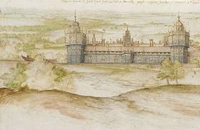
However, this is on the badge of the Borough of Epsom and Ewell and not anything specific to our Football club so my thoughts were that we should create a Motto for Epsom & Ewell FC. Now, many club mottos are in Latin so I turned my thoughts on the language of ancient Rome. (Actually they spoke more Greek than Latin in Ancient Rome, a fact that I learnt on a recent episode of QI but we will ignore that for now! – Also, did you know that Cleopatra was Greek and not Egyptian!)

Firstly, I looked for some examples of Latin Mottos that other clubs have adopted.

Bury FC has “Vincit Omnia Industria” (Hard Work Overcomes Everything),

Tranmere has “Ubi fides ibi lux et robur” (Where there’s faith, there’s light & strength).

I like Gillingham’s motto “Domus clamantium” (Home of the shouting men) and Everton’s is the splendid “Nil Satis Nisi Optimum” (Only the Best is Good Enough).

Maybe (due to the lack of any recent trophy) a more appropriate motto for us would be Queen Park’s “Ludere Causa Ludendi” (Play for the sake of playing)!

No-one has obviously informed Arsene Wenger that Arsenal’s motto is “Victoria Concordia Crescit” (Victory comes from harmony) and maybe West Ham’s motto at present should be “Nil deperandum” (Never give up).

My wife has just interjected and suggested that my personal motto should be “Ventis secundis (With a favourable wind) – actually the motto of H.M.S. Hood. Maybe I shouldn’t have eaten that Chicken Vindaloo last night!

The Modern Olympics has the famous motto “Citius, Altius, Fortius” (Swifter, Higher, Stronger) but the younger generation would probably be more familiar with “Draco dormiens nunquam titillandus” (A sleeping dragon must never be tickled) from Harry Potter.

A personal favourite of mine is the motto of the Addams family “Sic gorgiamus allos subjectatos nunc” (We gladly feast on those who would subdue us).

None of the above, however, would be suitable for our club.

I did try to create some original Latin mottoes myself but I am about as proficient in Latin as Brian was in Monty Python’s Life of Brian, when he painted on the wall “ROMANES EUNT DOMUS” which reads “People call Romans they go the house” instead of the intended “Romans Go Home!).

The only effort that I could come up with was:
“Lyndon sic in Omnibus” (presumably after an away defeat) though I did stumble across the following which may be more apt.

“Crux spes unica” (The cross is the only hope.)
This is the motto of the Notre Dame University but due to our frustration at the number of short corners and the complete lack of delivering a telling ball into the box this selection should certainly be considered.

“En Avant” (Forward.)
In a similar vein to the previous one the motto of Minneapolis could remind our players to reduce the number of sideways and backwards passes and to attempt to penetrate the opposition penalty area more often.

“Munit haec et altera vincit” (One defends and the other conquers.)
The motto of Nova Scotia would need to be amended to “Munit haec et altera doneus bylongballus” (One defends and the other is done by a long ball) in reference to the goals conceded to Molesey, Sandhurst and Camberley all at Moatside this season!

“Hic si stas, hinc eris” – (Here you stay, here you belong.)
This could be my number one choice – once we move into a new ground within the Borough of Epsom & Ewell of course! (Love this one too – Ed)

I would be interested to solicit opinions on this topic from other committee members, players and supporters. Please send a postcard with your choice of motto to;

Mrs Elspeth Willoughby,
32, The Drive,
Harrogate,
Yorkshire.

(She has nothing to do with the selection process but she does enjoy receiving postcards!)

Every Opponent A-Z
Over the years we have played many, many different opponents. Exactly how many is a difficult question, as it all depends on your definition. Are Camberley and Yorktown different to Camberley Town, or are Epsom Town different to Epsom F.C. or Epsom & Ewell F.C.?

In my analysis I have classed them as the same team, and will work through them all from A to Z. Some we have played many times, whilst others maybe just once or twice. Enjoy!
-----------------------------------------------------------------------------------

Chatham F.C. / Chatham Town: - Played 4 - W4 D0 L0 - F14 A3
Points per Game - 3.00 - Perfect

We met Chatham for the first time on 5th January 1929 at which point they were quite a good side, playing in the Southern League, although that season they dropped into the Kent League and remained there for the next 30 years. We still defeated a side containing four professionals by four goals to one at West Street.

Chatham are a very old club, and although the name had changed by 1983 to Chatham Town, so had ours, from Epsom Town to Epsom & Ewell. They, like us were one and the same, and were playing at Maidstone Road when we visited for an F.A.Cup tie in the September of that year. We won 2-1 with goals from Steve Hill and current Banstead Athletic Manager Russell Harmsworth, who still recalls the goal, a looping header. I also recall the journey home that day, bleeding from a cut in my foot all the way back to Ewell East station as a result of jumping over a wall and landing on a broken bottle. I still have the scar from the six stitches!

By the time we returned there in 1988 they were dark days, and there was talk that the F.A.Vase game would be the club’s last ever match. There was no programme issued and we cruised to a 5-0 win, eventually reaching the Fourth round that season, but they survived, and a few years later I saw a large stand and turnstile block appearing at the Maidstone Road end of the ground, where previously there had been a few steps of crumbling concrete terracing.

Our latest meeting was in our final season at West Street in October of 1992 for another Vase game, when we trailed at the break but forced extra time, eventually winning 3-1.

They are still at Maidstone Road, and currently play in the Ryman League, one step above us, although they are not one of the stronger sides there.

Chelmsford: - Played 16 - W5 D5 L6 - F26 A39
Points per Game - 1.25 - Below Average

This club were the pre-war forerunners of the current Chelmsford City, although they also used the atmospheric New Writtle Street for a home base.

We met for eight consecutive London League seasons and matches were fairly even between the sides, although the disparity in goal difference is largely due to some proper hidings we received over there; 1-5, 1-6, and 1-8. In 1935 they left to become a founder member of the Eastern Counties League, although they folded in 1938 and were replaced by a professional outfit, Chelmsford City, who joined the Southern

League that season and became one of its bigger clubs over the next thirty years.

Chelmsford City Reserves: - Played 4 - W0 D1 L3 - F5 A26
Points per Game - 0.25 - Horrible

After the war we remained in the London League for a few seasons. However, by now the Essex based side were much larger and we were meeting their Reserves instead. Things did not go well, and the darkest day in our playing history occurred on 14th February 1948 when we were eclipsed 14-0 in a League game there. In fairness they were obviously a very strong side, and I have recently found out that not only did they win the London League that year but they also won the Eastern Counties League too! Bearing this in mind, it’s possible and some slight consolation that they might not all have been Reserves out there on that dark day!

The club lost their ground in the nineties after a long drawn out saga, but recently relocated to the new Melbourne Park Stadium, and are currently pushing for a place in the National Conference this season. A picture of their old main stand is shown below.

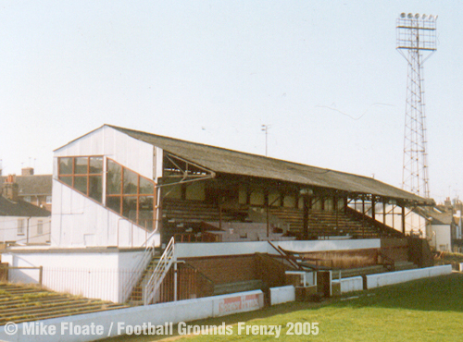

Cheltenham Town: - Played 1 - W1 D0 L0 - F3 A2 - Points per Game - 3.00 - Perfect

This one is a much nicer memory against a club that are now an established League outfit. We had an excellent F.A.Trophy run in 1981/82 and had just knocked out Alliance Premier League team Gravesend & Northfleet, but due to the delays with that tie, we had to travel West on a Thursday night, and to my eternal regret as a fifteen year old unable to get out of school and on the day of a train strike, I couldn’t make the journey that most of our players had to do by car, as no coaches were available either.

It didn’t matter though as goals from Steve Hill and a 35-yard scorcher from Tony Coombe put us two goals up against the then Southern League team. However, they fought back with two goals in the last ten minutes. Luckily there was just time for Tommy Tuite to score a typical poacher’s goal after 89 minutes to win it. Long term though, it’s fair to say that the defeat didn’t really do Cheltenham any harm!

Steve Dyke
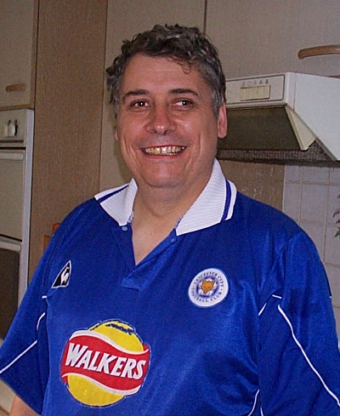
My Week

I’m going to take a bit of a liberty this week in the column. The liberty is this having got to a certain point – let’s call it the absolute deadline for writing your article say - and nothing footbally either involving my beloved Salts or the wider game as a whole has crossed my mind. Therefore I’m going to attempt one of those “My Week” columns you see so often in the newspapers, just mentioning in passing stuff that has attracted my attention.

Now I’m aware there’s a slight conceit here. Those columns are only generally awarded to people considered to have sparkling lives likely to be of interest to others - and I know I barely qualify. Indeed such is my scepticism of some of these type of articles I read, Matthew Paris for example writing “visited some old ruined castles in Catalonia after a 20 mile hike up the mountains” and a little voice in my head says are you sure its not “stumbled from my bed to the computer sending empty vodka bottles crashing about the place shattering all over my magazines” but maybe that says more about me.

So “my week” it is. Thursday saw me dipping in and out of the Parliament Channel watching the debate on giving prisoners the vote. It was interesting that some MP’s were saying very few prisoners want the vote. I thought now the jails are beginning to fill up with ex MP’s following the expenses scandal, maybe there is becoming more of a demand. All the while Silvio Berlusconi looks on at our strong response to relatively small acts of corruption and thanks God that he’s Italian.

Whilst we’re in Parliament the one couple who actually live there - the Speaker and his wife have hit the headlines. Sally Bercow did an article ostensibly about Valentines day where she appeared in a sheet and said probably in a smouldering voice that living under Big Ben “gives her ideas”. Blimey I’d best get me and Helen a Travelcard and get up there right away. (Sally Bercow, yum, yum! – Ed)

All speakers develop a catchphrase and persona for coping with the inevitable rowdiness of Prime Ministers Questions. I was particularly fond of Michael Martin firstly for proving it is possible to have a soft Glaswegian. When the boys were babies I would often use his catchphrase “I will not have shouting in the House” whilst carting a screaming baby around the room. It sometimes worked. When Sam was a baby the other most effective thing at getting him to sleep was Gerard Houllier’s Liverpool getting a 0-0 in the UEFA Cup – had him zonked in an instant. Thursday Night Europa league action on Channel Five, now there’s something for Chelsea fans to look forward to.

John Bercow’s persona in the chair is less avuncular Grandpa and more struggling supply teacher - maybe it’s because he’s short. To attempt to quieten the house he generally says in a pained “the bell is a signal for me” voice.

“ The public don’t like it and I don’t like it” - I’m just waiting for some wag to say

“that’s not what we heard!”

Otherwise a chunk of this week has been taken up with getting things ready for the sponsored walk to Guildford, mainly on setting up the Just Giving page. I did this last year for the great trek to Bedfont and once the first donation comes in I become quite an obsessive checker of the site – oh about 5 or 6 times a day. Now this is not a takeover bid but they wouldn’t let me create a group page - if you want to sponsor any of the walkers via justgiving you’ll have to come on to my page. To do this, go on to www.JustGiving.com and put Stephen Dyke in the Sponsor a Friend box. If you are sponsoring one of the others you can name check them in your message.

I’ve been reading a biography of Peter Cook this week. It’s not often I get into a book such that I’m really pursuing it to the finish – but Peter Cook was someone whose comedy I really admired. I finished it last night all 484 pages of it – I’m not going to bother reading biographies again to be honest - when I got to the end he died.

In half term we are going up North for a break to a self-catering house in Horwich, near Bolton and just around the corner from the Reebok stadium. One of the key tasks before the trip is to compile the family car CD for the journey. I’ve done all my bits - a mixture involving various obscure Irish and Welsh bands with the occasional Motown classic thrown in.

My current favourite band are three brothers from the end of the Lleyn Peninsular in North West Wales called “Cowbois Rhos Botwnnog” who are very very talented and worth checking out – Johnny meets Johnny Marr meets Leonard Cohen – in Welsh. They did a London Gig recently and I was one of 12 people present.

Last night was the time to select the kids tracks and I remembered the kind of thing I liked as a child. Whilst trawling through you tube I came across “Right Said Fred” by Bernard Cribbins. Someone has done a video of the song where Lego characters act it out – I can recommend it to anyone with young kids, mine loved it.

I also found out something else very useful last night – the Chuckle Brothers cannot sing to save their lives. I’m a big admirer of the Chuckle Brothers as virtually the last surviving practitioners of the art of slapstick comedy as used to be mainstream.

When Ian Paisley (senior) and Martin McGuinness were surprisingly getting on well running the devolved government in Northern Ireland people called them “The Chuckle Brothers”. It was well meant but I’m not sure I buy the parallel. What was happening at the Stormont Assembly, with people taking on jobs they had no hope of completing successfully – messing it up whilst saying “to me to you” ending up saying “Barry he’s coming… and he doesn’t look pleased” and running away.

On second thoughts ……

Cup Updates

Surrey Senior Cup
Quarter Finals
Leatherhead | 4-1 | Tooting & Mitcham United
Carshalton Athletic | V | Molesey
Raynes Park Vale | 8/3 | Metropolitan Police
Corinthian Casuals | V | Colliers Wood United
Semi-Finals
Raynes Park Vale / Metropolitan Police | V | Corinthian Casuals / Colliers Wood United
Leatherhead | V | Carshalton Athletic / Molesey

EL Records Combined Counties League Cup
Quarter Finals
Farleigh Rovers | 2-1+ | Molesey
Farnham Town | 0-1 | Sandhurst Town
Mole Valley SCR | 2-1 | Camberley Town
Wembley | 1-0 | Egham Town
Semi-Finals
Sandhurst Town | V | Farleigh Rovers
Wembley | V | Mole Valley SCR

F.A.Vase Quarter-Finals – 5th March
Poole Town | 2-1 | Torpoint Athletic
Wessex League - 2/22 |  | South Western League - 3/20
Coalville Town | 1-0 | Leiston
Midland Alliance - 2/23 |  | Eastern Counties League - 1/22
Kings Lynn Town | 3-1+ | Rye United
United Counties League - 2/21 |  | Sussex League - 6/20
Dunston UTS | 1-2 | Whitley Bay
Northern League - 11/22 |  | Northern League - 5/22

Cove F.C. Club History
Cove F.C. were formed in 1897 by a group of local people playing on a field behind their favourite Public House. Moving to a more central location, Cove Green became their home until 1973, when they moved to their present ground at Oak Farm. Playing their football in The Surrey Leagues, Cove enjoyed success for many years, winning more than their fair share of silverware, including the League Championship 3 years in succession and a double in that period.

In 1973, the club were accepted into the Hampshire Leagues, but had to leave 'The Green' for safety reasons. The Division 4 Championship was won at the first attempt, and the Division 3 title followed 2 years later. After a couple of seasons, Cove finished Runners-Up in Division 2, but decided to withdraw from this league due to the time taken to away matches in Portsmouth or Southampton, before the M3 motorway was built. Thus they returned to the more local Combined Counties League in 1980 and won the League Cup, beating close neighbours and rivals Ash United. Since moving into their new home, many changes have taken place at Oak Farm with the installation of floodlights, a concrete perimeter wall and stand in their quest to house senior non-league football. These achievements are the more remarkable with Farnborough Town and Aldershot Town just down the road.

In 1990, Cove joined the Isthmian League after finishing third. New manager ‘Chick’ Botley assembled a squad strong enough to finish a respectable fourth in their first season. Two more successful seasons followed narrowly missing out on promotion, once on a final day defeat by the new Aldershot Town. Due to the ever-spiralling cost of football at this level, Cove were forced to withdraw from this League and after three unsuccessful attempts to join the Wessex League, had to revert back into The Combined Counties League.

After finishing bottom of the League two years running, Cove Football Club appointed Steve Beeks, a young man with no managerial experience, but a good playing record which included a period as professional at Aldershot until their demise in 1992. Within twelve months Cove were on their way back, having regained some respect among the local clubs, and were no longer the ‘Whipping Boys’, finishing a creditable 8th, allowing entry back into the top competitions. Season 2000-2001 saw Cove reach the 5th round of the F.A. Vase beating some more senior clubs along the way, before losing out to Chippenham Town, and a F.A. Cup victory at Ryman Division One side Bognor Regis. The Premier Challenge Cup was won with a 3-0 victory over Walton Casuals and was soon followed by the victory over closest rivals, AFC Wallingford, which ensured the League Championship, breaking all league records on the way, which included reaching the magic 200 goals scored in all competitions to complete a memorable season.

No resume of Cove F.C. would be complete without mentioning their current President, Ron Brown, who in 1990 received an F.A. award for 50 years service to Cove F.C., including 35 years as Secretary. Ron retired in 1982 passing the reins to his son Graham who has himself completed 28 years in the job. Sadly Ron passed away in 2009 after 70 years service including 20 years as Club President.

This Season’s Match Sponsors
Fixture | Date | Match Sponsor | Ball Sponsor
Shoreham (F.A. Cup) | 14/08/10 | Epsom & Ewell F.C. Committee
Dorking | 17/08/10 | Pete Beddoe
Mole Valley SCR | 21/08/10 | Richard Lambert
Flackwell Heath  (F.A. Cup) | 28/08/10 |  | Dick & Dom
Molesey | 09/10/10 |  | Pete Beddoe
Raynes Park Vale | 06/11/10 | Mid-Surrey Mencap
Bracknell Town  (F.A. Vase) | 14/11/10 | Tony Jeffcoate
St Neots Town  (F.A.Vase) | 14/12/10 | Epsom Coaches
Sandhurst Town | 29/01/11 | Dave and Nicola Beddoe | Joon Wong
Croydon | 08/02/11
Camberley Town | 05/03/11 |  | Joon Wong
Cove | 08/03/11
Chertsey Town | 15/03/11
Hanworth Villa | 19/03/11
Horley Town | 22/03/11
Colliers Wood United | 05/04/11 | Nathan Lambert
Bookham | 09/04/11 | Tony Foster
Wembley | 12/04/11 | Steve Dyke
Chessington &  Hook United | 19/04/11 | Liz and Doug Burns
Egham Town | 23/04/11
For League Matches:

Match sponsorship is available for £35.00.

Match ball sponsorship is available for £20.00.

For Cup Matches:

Match sponsorship is available for £45.00.

Match ball sponsorship is available for £25.00.

Match sponsorship includes admission, programmes, advertising
and hospitality for two.

Match ball sponsorship includes admission, programme, advertising
and hospitality for one.
Interested? Speak to Tony Jeffcoate on 07960 084225 now!

The Epsom & Ewell F.C. Fund-Raising Exercise
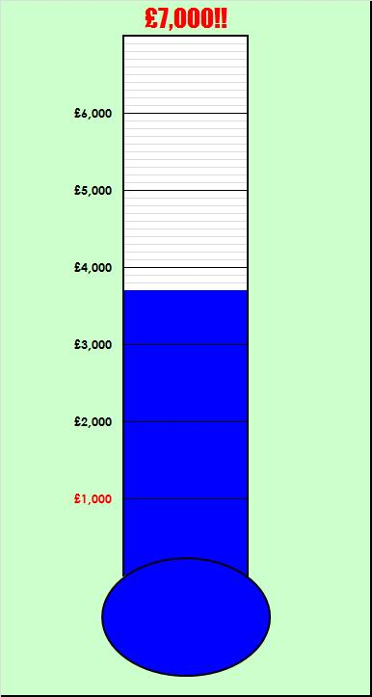

As advised at the start of the season, we need to raise funds for the club. You will note we have had a massive jump up to £3,700 as we factor in the amounts pledged for the Sponsored Walk and Period 4 Golden Goal Bingo Ticket Sales. We are aiming for a target of £7,000 but still need YOUR help.

You will all be aware of our Golden Goal Bingo Tickets, and we could really do with some more sellers. Every supporter ought to be able to sell between five or ten each to friends and family and if anyone wishes to do this, please let me know, as our final batch of tickets for the March and April period are out now.

We have other items too: Were you there when Epsom and Ewell played Aldershot Town in the last League match ever played at our old ground in West Street?

Alternatively, you may never have even got the chance to see the ground before it disappeared under housing, shortly after we left there in 1993.

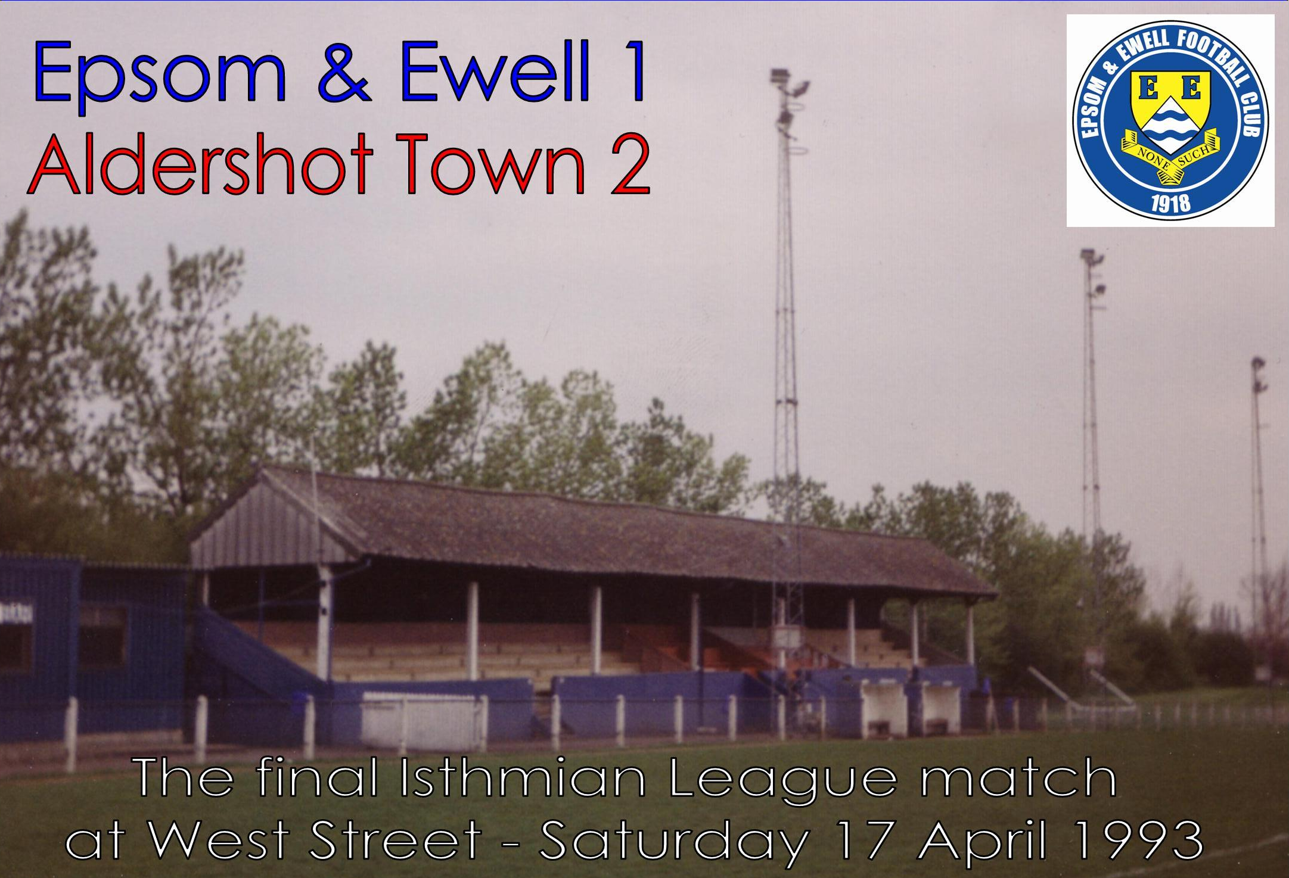
Well, now’s your chance. Aldershot Town recorded the game on video, and gave the club twelve copies to sell on. I was one of the twelve that purchased one and have now converted it onto DVD. We are now taking orders, and they are available for £10, so please let me know if you would like a copy (pictured above).

In addition, we still have copies of the 50 Epsom Legends, a 108-page limited edition book available for £10 and covering biographies of the 50 greatest people to be associated with the club in its entire history. Again, just let me know if you would like one (pictured right).

Please help by supporting your club.
We really need your assistance!
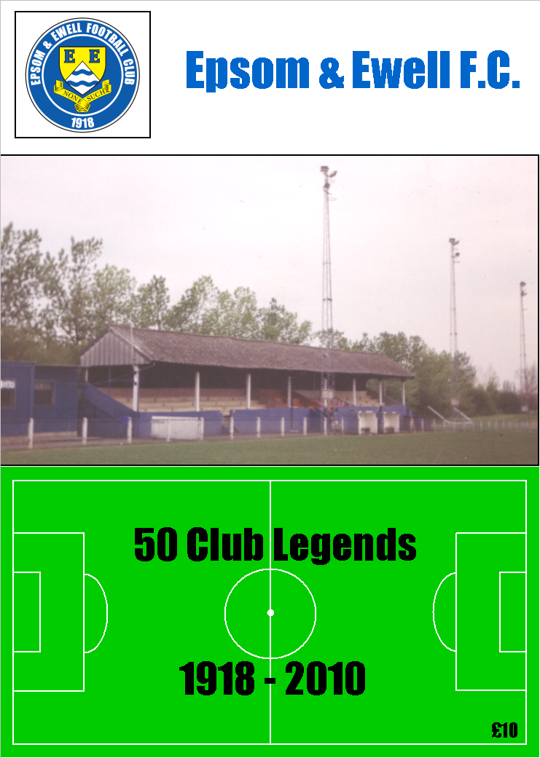

Combined Counties League – Premier Division
Tuesday 8th March 2011 - Kick-off 7.45 p.m.
Epsom and Ewell F.C.  (Royal Blue & White hoops) | V |  |  | Cove F.C.  (All Red)
Paul Borg | 1 |  | 1 | Garry Aulsberry
Matt Smith | 2 |  | 2 | Tom McGarry
Dale Hennessey | 3 |  | 3 | Kurt Greenway
(capt) Alex Rodrigues | 4 |  | 4 | Ken During
Anthony Panayi | 5 |  | 5 | Kayode Oladipo
Paul West | 6 |  | 6 | David Johnston
Ben Hayward | 7 |  | 7 | Sean Bradley
Ramzi Bedj Bedj | 8 |  | 8 | Jack Naeger
Hinga Amara | 9 |  | 9 | Alex Jeffers
Kyle Hough | 10 |  | 10 | Bimal Balal
Tony Cuff | 11 |  | 11 | Sean Bradley
Russell Banyard | 12 |  | 12 | James Scott
Neil Harrowing | 13 |  | 14 | Wayne Noad
Alex McGregor | 14 |  | 15 | Aaron France
Steve Symes | 15 |  | 16 | Zac Harkan
Andy Amfo-Brobbey | 16 |  | 17 | Harry Roberts
Lyndon Buckwell | MANAGER |  |  | Koo Dumbuya
Tony Coombe | ASSISTANT |  |  | Simon Brand
Barry Barnes | COACH
Ken Jones | PHYSIO |  |  | Phil Ties
REFEREE: A.Groves (Windsor)
ASSISTANT REFEREES: M.Ford (Sutton), S.Earl (Mitcham)

OUR NEXT FIRST TEAM MATCH AT MOATSIDE

Epsom and Ewell v Chertsey Town

Tuesday 15th March 2011 - Kick-off 7.45 p.m.

Combined Counties League – Premier Division

